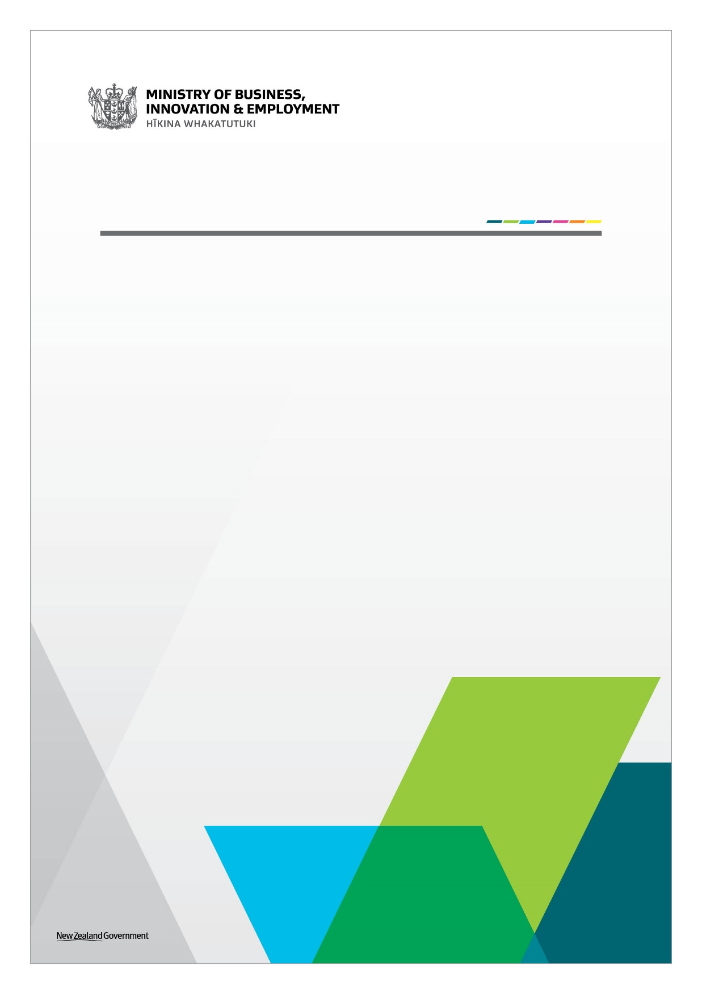
Tourism Communities: Support, Recovery and Re-set Plan

Business Advice Implementation Grant
Guide and Application Form
August 2021

Business Advice Implementation Grant: Guide for Applicants
The Government has allocated additional funding to support tourism businesses through recovery from COVID-19 through the $200 million Tourism Communities: Support, Recovery and Re-set Plan (the Plan).
The Plan includes $10 million in grants to implement advice received through the Business Advisory Support initiative or an alternative satisfactory channel. The Business Advisory Support initiative complements the Business Advice Implementation Grants by providing businesses with up to $5000 (excluding GST) to receive expert advice and support.
Tourism businesses can access funding through other initiatives in the Plan alongside the Business Advice Implementation Grant if required, including Business Advisory Support (through the Regional Business Partner Network) and the Tourism Kick-start Fund.
The organisations delivering the Business Advice Implementation and Tourism Kick-start Fund initiatives are called Lead Entities (with support from the local Regional Business Partners). Lead Entities have local knowledge and expertise, and have been agreed with the five districts. The Lead Entities are:
- ChristchurchNZ (for Kaikōura and Mackenzie Districts)
- Great South (for Southland District)
- Queenstown Lakes District Council (for Queenstown Lakes District)
- Development West Coast (for Westland District).
Confidentiality: The application is confidential. Limited information will be published online by the Lead Entity for accountability and transparency purposes. This is expected to be limited to the name of the business, district and grant amount approved. The application may be subject to the Official Information Act 1982, or Local Government Official Information and Meetings Act 1987.

Application process for the Business Advice Implementation Grant

* https://www.mbie.govt.nz/immigration-and-tourism/tourism/tourism-recovery/tourism-communities-support-recovery-and-re-set-plan/
Eligibility Criteria
You must:
- Be a GST registered business, or GST registered prior to COVID-19 (2019/20 financial year);
- Have a New Zealand Business Number (if you do not have a New Zealand Business Number, you can register here: https://www.nzbn.govt.nz/get-an-nzbn/);
- Be operating in a commercial environment;
- Be a privately‐owned business or Māori Trust or incorporation under the Te Ture Whenua Māori Act 1993 or similar organisation managing Māori assets under multiple ownership;
- Be a tourism business, which is defined as a business where at least 50 per cent of its operational output is purchased by tourists (domestic or international), for example: Accommodation, Arts and Recreational Services, Food Services, Transport Services or Retail Trade. This can include service businesses whose output is purchased by tourism businesses;
- Be physically based within at least one of the five districts: Queenstown Lakes District, Southland District, Kaikōura District, Mackenzie District, or Westland District (one grant per business operation); and
- Have received advice from the Regional Business Partner (RBP) Network, or an alternative channel that has been approved by the Growth Advisor employed by the Lead Entity.
Charitable Trusts, Incorporated Societies, Non-business entities, Local and Central Governments are ineligible.
Duration
The Business Advice Implementation Grant will be open for an initial one year period from 31 August 2021 to 31 August 2022. A review to extend the time period is expected to occur based on funding availability.
Applications will be assessed on a case-by-case basis as they are received to enable businesses to apply when they are ready, help spread the workflows and for budget forecasting. The pace of this assessment will be dependent on the volume of applications received for the Business Advice Implementation Grant.
Grant conditions
The Business Advice Implementation Grant available for eligible businesses is a maximum of $5000 per business operation (excluding GST). This grant is intended to support businesses to implement advice they have received through the Business Advisory Support or a satisfactory alternative provider.
The Business Advice Implementation Grant is only available to implement advice that the Lead Entity has approved. Advice must have been provided in a written format, so there is an audit trail for the grants. This could be as simple as a short description outlining the advice provided.
Should the Growth Advisor (employed by the Lead Entity) determine the advice as not satisfactory, then the business would be eligible to receive Business Advisory Support to get the necessary expert advice (up to $5,000 per business operation) and then receive a grant for implementing this advice.
The grant will be contracted on the Lead Entity terms, which the Lead Entity will supply to eligible businesses. The grant will be contingent upon acceptance to these terms.
In Scope
The Business Advice Implementation Grant can be used for operational activities in one or more of the following categories:
- HR & Employee Relations and Legal (e.g. Contract law, legal requirements)
- Financial and Cashflow Management (e.g. budgeting, forecasting, scenario planning)
- Health and Wellness (e.g. employee mental health & wellness, resilience building and stress management)
- Business Continuity Planning (e.g. Workforce planning, risk management)
- Marketing Strategy (e.g. digital marketing strategy, branding, digital advertising)
- Digital Enablement Strategy (e.g. Website development, automated booking)
- Hibernation and exit advice (e.g. Liquidation support)
- Management Capability Training and Coaching.
Out of scope
The Business Advice Implementation Grants cannot be used for:
- Advice already implemented and paid for (i.e. historic payments are ineligible)
- Anything that is not detailed in the professional advice already received
- Capital expenditure (e.g. purchasing computer hardware, vehicles, boats, planes)
- Employees of the business for advice implementation to mitigate the risk of conflicts of interest or perverse behaviour
- Any other situation where an actual, perceived or potential conflict of interest may exist, without prior written approval from the Lead Entity.
Payment
Businesses must provide quotes to the Lead Entity for implementing the advice. You must receive approval from the Lead Entity before an expense is paid.

Reporting and accountability
The business must confirm to the Lead Entity that the work has been undertaken in accordance with the advice provided and report the categories of expenditure. The business must retain evidence of the expenditure for transparency and audit purposes.
The Lead Entity will report to the Ministry of Business, Innovation & Employment on a monthly basis to monitor the success of the Business Advice Implementation Grants. The Lead Entity will also publish the names of businesses that have been approved grants and the grant amounts on their websites.
Business Advice Implementation Grants: Completing this form
If you need any assistance with completing this form, please contact the Lead Entity for your District highlighted here.
Please complete the form electronically, and attach the following:
☐ Your bank account details and third party verification (such as a bank statement or screenshot of your internet banking).
☐ Proof of GST registration (e.g. screenshot from MyIR accounts tab showing the word GST and your business name).
☐ Evidence of advice your business intends to implement (from either the RBP Network or satisfactory alternative provider).

☐ Quotes for the advice your business intends to implement.

Submit your completed application to the Lead Entities highlighted here. Applications will be assessed on a case by case basis and must be received by the Lead Entity before 31 August 2022.
Note: There is a 20MB size limit. For larger applications, please separate them into different emails.
Proposal checklist
Before you apply be sure to complete the following:
☐ Read the supporting information on the website.
When filling out this form please ensure:
☐ All answers are typed into the space provided for each section in font no smaller than size 10 point.
☐ You provide the information required for each question.
☐ You have read and understood the declaration details outlined in Section 4 and have signed the declaration.
Evidence
When the Lead Entity assesses proposals against the eligibility and/or the assessment criteria, we will consider whether the evidence provided supports the claims, as well as the quality of that evidence. Where questions ask for evidence to support claims, it is highly recommended that you provide reference sources that attest the accuracy and quality of the evidence. The Lead Entity will assess the application using the information provided by the applicant. In some cases the Lead Entity may use a third party to assist with verification of decisions.
Business Advice Implementation Grants: Application Form
Section 1: Proposal and applicant key details
Please enter answers in the right-hand column.
1.1 Applicants’ key details
Business legal name:
Business trading name:
Physical business address, including postcode:
Business website:
GST registration number:
New Zealand Business Number:
Key point of contact (delegated by Business owner/s):
Email address: |  | Telephone:

Section 2: Eligibility
Please read this section carefully
The Business Advice Implementation Grant intends to support tourism businesses with the costs associated with implementing the changes recommended to their business after receiving advice.
You must meet all of the eligibility criteria below to qualify for the Business Advice Implementation Grant.
2.1 Eligibility criteria
1: Is the business a tourism business?  For the purposes of this grant, the definition of a tourism business is:  All businesses that are directly and indirectly affected by the lack of visitors within the five districts.  At least 50 per cent of the operations’ output is purchased by visitors (domestic or international), or the operations’ output includes a tourism-characteristic product. | Tourism Business: You must be a Tourism characteristic business where:  - at least 50 per cent of the operations’ output is purchased by visitors (domestic or international) prior to COVID-19. This can include service businesses whose output is purchased by tourism businesses.  Yes ☐ No ☐  Tourism characteristic – Identify the characteristic of your business as defined in the Businesses Demography Statistics, 2019:  - Accommodation ☐  - Arts and Recreational Services (e.g. activities and attractions) ☐  - Food Services ☐  - Transport Services ☐  - Retail Trade ☐  - Other (please specify) Click or tap here to enter text.
2: Is the business physically based within at least one of the five districts?  Businesses with multiple sites (i.e. as part of a chain) would only be eligible if the business operation is physically based within one of the five districts.  The Business Advice Implementation Grant provides one grant per business operation. | Business location: Your business must be physically located within the geographical boundaries of one (or more) of the following five districts:  - Queenstown Lakes District ☐  - Southland District ☐  - Westland District ☐  - Mackenzie District ☐  - Kaikōura District ☐  Are you applying for the Business Advice Implementation Grant for a business operation in another eligible district?  Yes ☐ No ☐  If yes, please specify the district(s) Click or tap here to enter text.

2.2 What is your tourism business?
In this section, we want to understand a summary of your business, current situation and the future outlook.
Please provide a brief description of:  - the purpose of your business  - the percentage of the operations’ output purchased by visitors (domestic or international) prior to COVID-19  - impacts of COVID-19  - action taken to manage those impacts  - future outlook for your business.  This can include service businesses whose output is purchased by tourism businesses. | Word limit of 400

Section 3: Business advice
3.1 What advice have you received to support your application?
In this section, we want to understand the advice you have received.
In your response, please provide as much detail as possible.
Has your business received advice?  If you received advice that is no longer relevant to your business, you may wish to apply for the Business Advisory Support through the RBP Network. | Yes ☐ No ☐  If yes, is this advice still relevant for your business?  Yes ☐ No ☐
Who provided this advice? (e.g. RBP Network Advice or alternative provider)
Please provide the Advisor’s name and organisation

When was this advice provided? | Please select a date below  Click or tap to enter a date.
Was this advice provided in a written format?  The Lead Entity is unable to approve verbal advice. | Yes ☐ No ☐  If yes, please attach evidence of advice received.
Which of these categories does the advice you received broadly fall into? | Continue business operations ☐  Go into hibernation ☐  Cease business operations ☐

3.2 Implementing advice
In this section, we want to understand the level of government support you are looking for and how the Business Advice Implementation Grant will be used to support your business.
In your response, please provide as much detail as possible.
Amount of funding sought (excl. GST)
The maximum grant entitlement is up to $5,000 excluding GST.

When do you require (or expect to require) this funding? | Please select a date below  Click or tap to enter a date.
What categories of advice are you intending to implement? | Please select the categories that best describe how you intend to spend the grant:  - H& Employee Relations and Legal ☐  - Financial and Cashflow Management ☐  - Health and Wellness ☐  - Business Continuity Planning ☐  - Marketing Strategy ☐  - Digital Enablement Strategy ☐  - Hibernation and exit advice ☐  - Management Capability Training and Coaching ☐
Please provide a short description of how you intend to implement the advice for example:  My business is no longer viable and I need specialist advice from experts to close my business. I need to implement the steps on the following link https://www.business.govt.nz/tax-and-accounting/closing-down/closing-your-business/  Or  My business is likely to be viable or much better off if I upgrade my website with automated booking functions and undertake workforce planning scenarios.  Expenditure must align with advice received. Capital expenditure is ineligible. | Word limit of 400

Section 4: Declaration by applicant
The contracting entity is compliant and will continue to comply with all applicable laws, regulations, rules and professional codes of conduct or practice including (but not limited to) health and safety and employment practices.
Yes: ☐ No: ☐
Has the applicant or the contracting entity ever been insolvent or subject to an insolvency action, administration or other legal proceedings?
Yes: ☐ No: ☐

Has any individual in the Applicant’s team (including the Applicant’s Leadership Team, directors, partners, or trustees, or any key members of the project) ever been insolvent or subject to an insolvency action, administration or other legal proceedings, or actively involved in any organisation which has?
Yes: ☐ No: ☐

Has any individual in the Applicant’s team (including the Applicant’s Leadership Team, directors, partners, or trustees, or any key members of the project) ever been adjudged bankrupt or is an undischarged bankrupt?
Yes: ☐ No: ☐

Has any individual in the Applicant’s team (including the Applicant’s Leadership Team, directors, partners, or trustees, or any key members of the project) ever been under investigation for, or been convicted of, any criminal offence?
Yes: ☐ No: ☐

Are there any actual, potential or perceived conflicts of interest that the applicant or any of the key personnel have in relation to this project. For example if the Growth Advisor is related to the business owner(s), this would be a conflict of interest. This may not be an issue, as the business owner(s) can work with a different Growth Advisor.
Yes: ☐ No: ☐
If you answered “Yes” to any of the above questions, please provide a description below:
By completing the details below, the applicant makes the following declarations about its application to the Business Advice Implementation Grant (“application”):

☐ The statements in the application are true and the information provided is complete and correct, and there have been no misleading statements or omissions of any relevant facts nor any misrepresentations made;
☐ I have secured all appropriate authorisations to submit the application, to make the statements and to provide the information in the application;
☐ I have obtained the permission of my business owner(s) to provide the information contained in this application and those individuals are aware of, and agree to, the Terms and Conditions of applying for the Business Advice Implementation Grant;
☐ I understand that the application may be subject to the Local Government Official Information and Meetings Act 1987 (LOGIMA) and/or the Official Information Act 1982 (the OIA). The LOGIMA and OIA may enable information to be withheld under certain conditions;
☐ I have no actual, potential or perceived conflict of interest (except any already declared in the application) in submitting the application, or entering into a contract to carry out the project. Where a conflict of interest arises during the application or assessment process, I will report it immediately to the Lead Entity by email;
☐ I understand that the falsification of information, supplying misleading information, or the suppression of material information in this application, may result in the application being eliminated from the assessment process and may be grounds for termination of any contract awarded as a result of this application process; and
☐ I consent to the Lead Entity undertaking due diligence including any third party checks as may be required to fully assess the application.

Signature of applicant
This acknowledgment must be signed by a person with the legal authority to commit your organisation to a transaction (e.g. Chief Executive)
Name
Title
Organisation

Signature

Date | Click or tap to enter a date.

Section 5: Attachments
Please attach evidence of:
- Your bank account details and third party verification (such as a bank statement or screenshot of your internet banking);
- Proof of GST registration (e.g. screenshot from MyIR accounts tab showing the word GST and your business name);
- Evidence of advice your business has received and intends to implement (must be in a written format);
- Quotes for the advice your business intends to implement; and
- Any additional information you consider necessary to support your application. Note that there is a 20MB size limit. For larger applications, please separate them into different emails.

